Name | : | Mr. GOPALAKRISHNAN S | 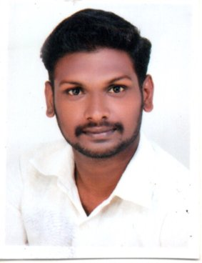
Designation | : | Assistant Professor
Department | : | Management Studies
Educational Qualification | : | B.Tech (Civil Eng.), MBA
Area of Specialization | : | Marketing Management and Human Resource Management
Publications | : | Gopalakrishnan S and Mr.P.Guru, “Gender Issues in Entrepreneurship Development” Emerging Management and Technology Practices, Shanlax Publications, pp 40 – 42, ISBN: 978-81-944228-0-8
Project Details | : | PG: Consumer Perception of Buying Cars with Reference to Maruti Suzuki, Thanjavur.  UG: A Study on Biodegradable Waste Generation in Thanjavur District.
Awards and Achievements | : | Best Paper Presenter Award in Two Day National Conference on “Sustainable Development through Technology and Management” 10th & 11th Oct 2018 at Periyar Maniammai Institute of Science & Technology.
Contact Address | : | Mr.Gopalakrishnan S  Assistant Professor  Department of Management Studies  Periyar Maniammai Institute of Science & Technology  Periyar Nagar, Vallam, Thanjavur – 613403  E Mail: gopalakrishnan.s@pmu.edu

